Age Adjustment
Prepared by Gerald Schafer, June 2016
Often, comparisons of population health indicators are expressed as crude and/or age adjusted rates. Age adjustment modifies the calculations by making it as if the various samples came from populations that had the same age structure.
Figure 1. Crude and Age Adjusted Incidence of End-Stage Renal Disease Related to Diabetes Mellitus (ESRD-DM) per 100,000 Diabetic Population, United States, 1980–2008 (CDC)
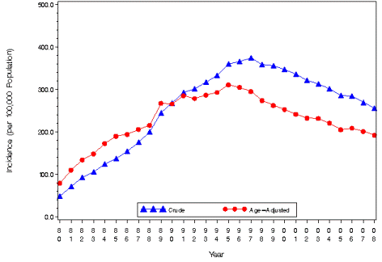
Question 1: Describe the changes in crude and age-adjusted incidence of end-stage renal disease in Figure 1. Any ideas as to why the incidence has changed as it has, and why the crude rate crossed over the age-adjusted rate around 1991?

The goal of this activity is to discover how age adjustment impacts rates of a condition through an exploration of publically available cancer mortality data.

Step 1. Go to http://wonder.cdc.gov/cancermort-v2012.HTML and generate cancer mortality data, grouped by year and state. Paste into Excel and clean up the data so you end up with a sheet that looks like Figure 2, in this and other figures with all 50 states and Washington DC.
Figure 2. Spreadsheet Example 1
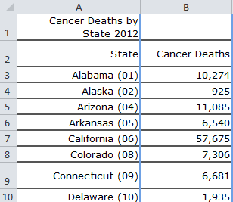
Step 2. Go to https://www.census.gov/popest/data/state/totals/2012/ and access 2012 population data by state. Paste beside your cancer death data. Then divide cancer deaths by the population and multiply by 100,000 to give a crude rate for cancer deaths by state. Your sheet should now look like Figure 3.
Figure 3. Spreadsheet Example 2
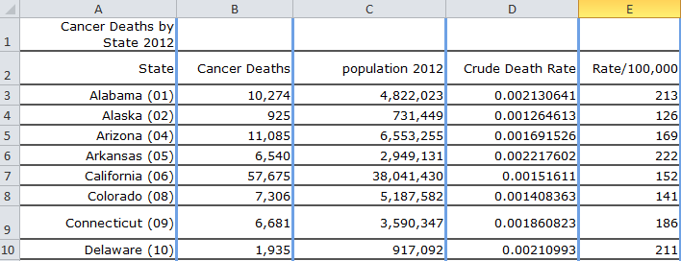

Step 3. Go back to CDC Wonder and generate age-adjusted data and add it to your spreadsheet. Then, using this Excel statement =IF(F3>E3,"Age adjusted","Crude") determine whether the age adjusted or crude rate is higher. Your spreadsheet should now look like Figure 4.
Figure 4. Spreadsheet Example 3.
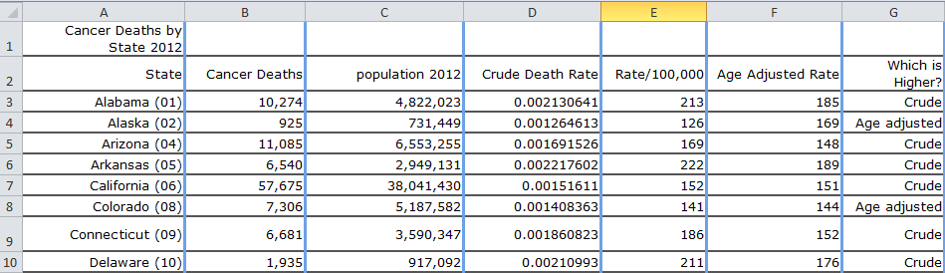

Step 4. Download the Excel file with median ages of the residents of each state from 2014 and paste them into your spreadsheet. Be sure to sort by state before pasting. http://www.statista.com/statistics/208048/median-age-of-population-in-the-usa-by-state/
Step 5. Sort by column G to group the states where the crude or age adjusted rates are higher, as in Figure 5.
Figure 5. Spreadsheet Example 4.
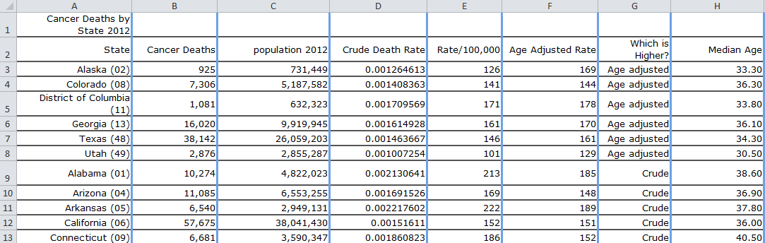

Step 6. Calculate average median ages for the six states where “age adjusted” is higher, and the 45 states where “crude” is higher. Insert your completed spreadsheet here.

Question 2. Seeing the results from Step 6 above and knowing what you do about cancer (who gets cancer more, young people or older people?) why do health researchers age adjust data that compares states or regions where the age structure of the populations are not the same?

Question 3. Speculate with explanations: Which state, Florida or Alaska, do you think has a higher crude death rate? How do you think age adjustment would change the rates of each state? If both states had the same age structure, which do you think would have the higher death rate?

